Below is the validation added screenshot. I have added client side validation.PremiumCalculator component with client-side validation added to ensure all fields are filled correctly before submitting the form.
• Added validation for empty fields and numeric ranges.
• Displayed error messages below each field.
• Disabled the submit button until the form is valid.

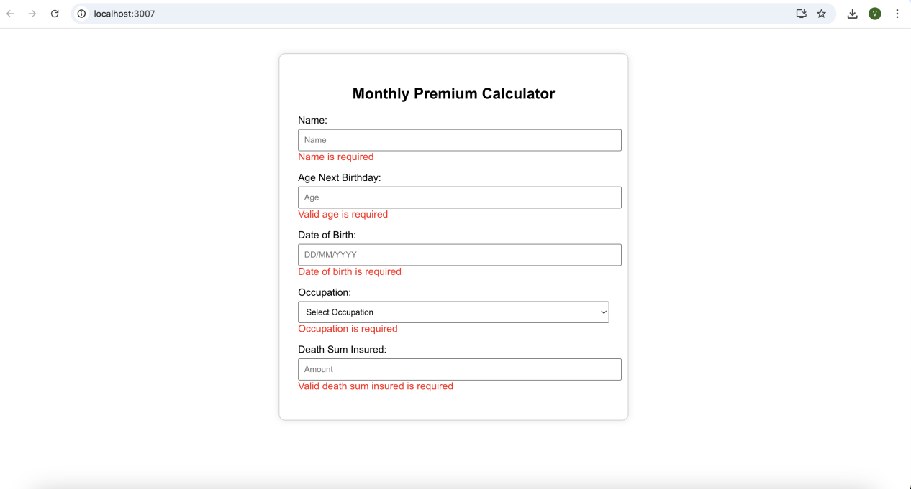
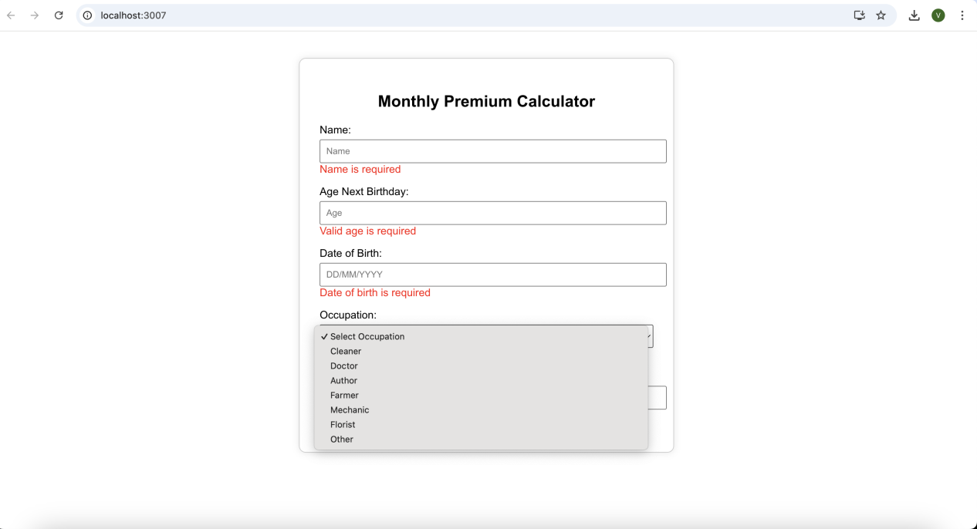

Validation successfully working. Please check the below screenshot.

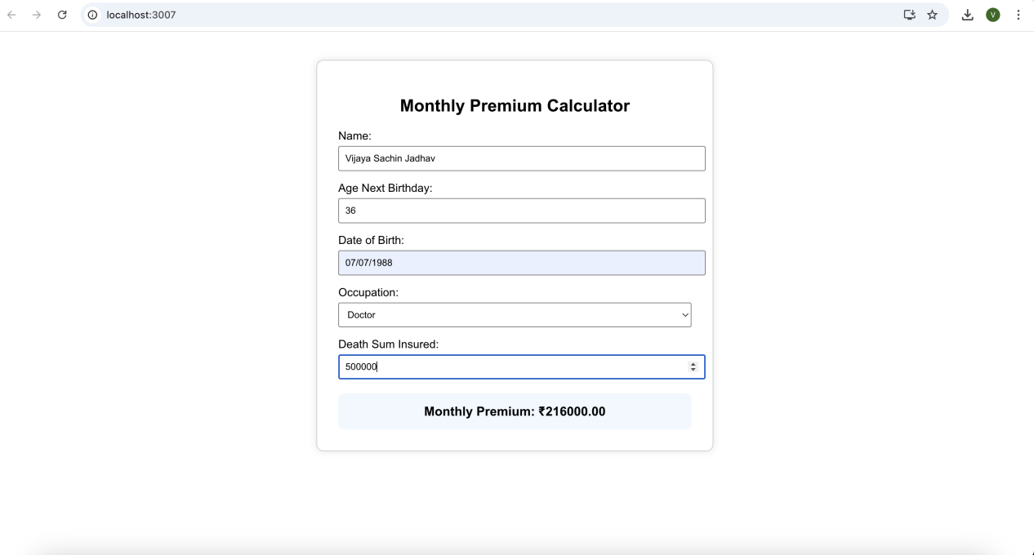

Swagger Testing API UI

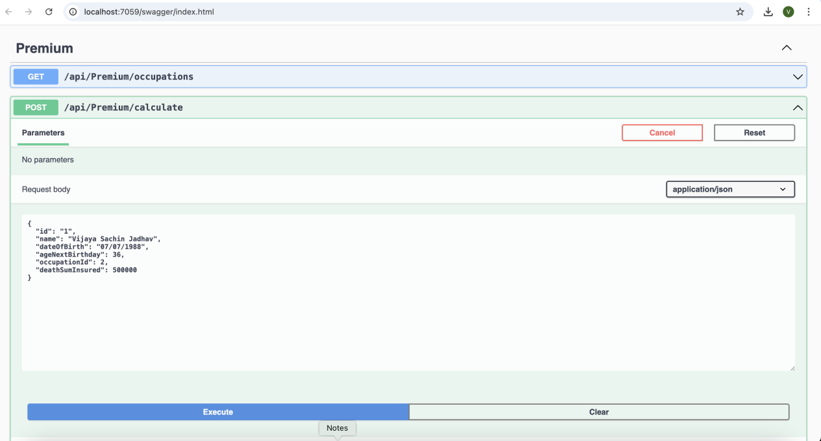
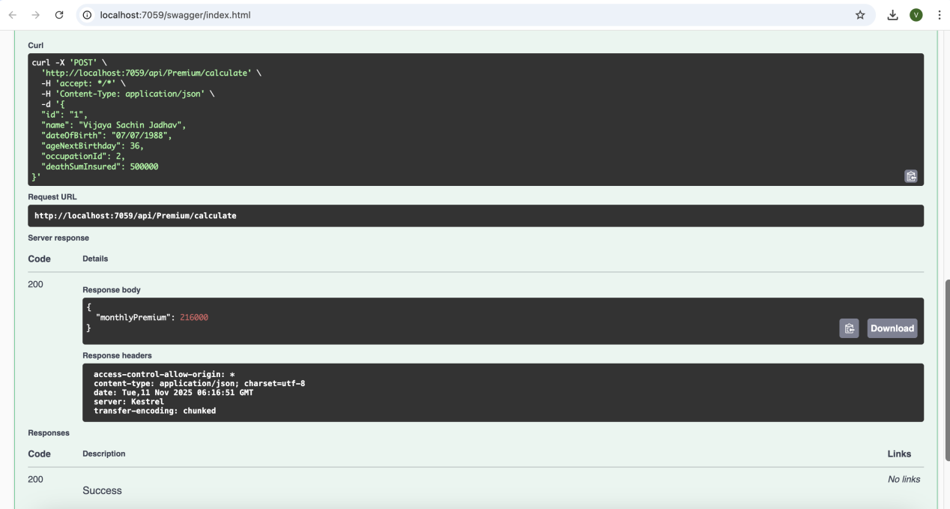
Above API is working fine.

